**DAILY ONLINE ACTIVITIES SUMMARY**

|  |  |  |  |  |  |  |  |  |
| --- | --- | --- | --- | --- | --- | --- | --- | --- |
| **Date:** | **23-5-2020** | | | | | **Name:** | **Prajna** | |
| **Sem & Sec** | **8th sem ‘B’** | | | | | **USN:** | **4AL16CS067** | |
| **Online Test Summary** | | | | | | | | |
| **Subject** | | **-** | | | | | | |
| **Max. Marks** | | **-** | | **Score** | | | **-** | |
| **Certification Course Summary** | | | | | | | | |
| **Course** | **Getting started: Hadoop** | | | | | | | |
| **Certificate Provider** | | | **Great Learning** | | **Duration** | | | **30min** |
| **Coding Challenges** | | | | | | | | |
| **Problem Statement:**1**.** Write a java program to check given two strings are anagram or not. | | | | | | | | |
| **Status: Completed** | | | | | | | | |
| **Uploaded the report in GitHub**  **GitHub link:** | | | | | **Yes**  **https://github.com/alvas-education-foundation/prajna_k** | | | |
| **If yes Repository name** | | | | | **prajna_k** | | | |
| **Uploaded the report in slack** | | | | | **yes** | | | |

Online Test Details: (Attach the snapshot and briefly write the report for the same)

Certification Course Details: (Attach the snapshot and briefly write the report for the same)

Coding Challenges Details: (Attach the snapshot and briefly write the report for the same)

1) certification course

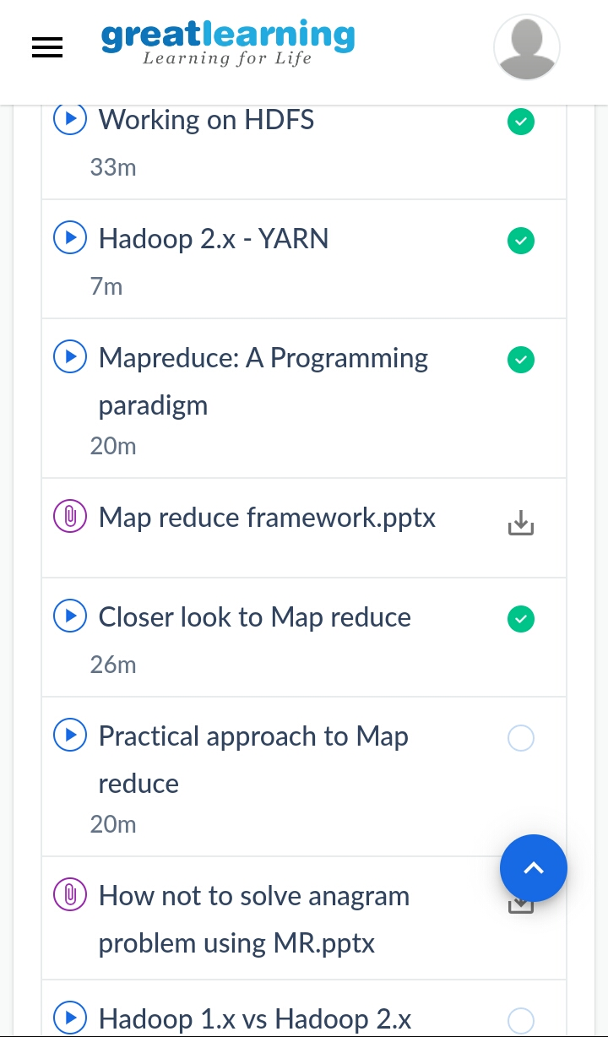

2) coding challenges

Program 1

public class Solution {

public static boolean anagram_test(String str1, String str2) {

if (str1 == null || str2 == null) {

return false;

} else if (str1.length() != str2.length()) {

return false;

} else if (str1.length() == 0 && str2.length() == 0) {

return true;

}

int[] count = new int[256];

for (int i = 0; i < str1.length(); i++) {

count[str1.charAt(i)]++;

count[str2.charAt(i)]--;

}

for (int num : count) {

if (num != 0) {

return false;

}

}

return true;

}

public static void main(String[] args) {

String str1 = "wxyz";

String str2 = "zyxw";

System.out.println("String-1 : "+str1);

System.out.println("String-2 : "+str2);

System.out.println("Check if two given strings are anagrams or not?: "+anagram_test(str1,str2));

}

}

|  |
| --- |
|  |
|  |  |
|  |  |
|  |  |
|  |  |
|  |  |